**Bellabeat Case Study: Analysis**

**How Trends in Sleep, Motivation, and Exercise Barriers Can Improve Bellabeat Products**

Clarissa McCarthy

March 15, 2024

Table of Contents

Background 3

Libraries 3

Demographics 3

Popularity of FitBit Features 6

Effectiveness of Fitness Device Sleep Features 7

Average Hours of Sleep 7

Impact of Fitness Device on Sleep Patterns 8

Exercise Motivation & Weight Loss 10

Motivators for Exercise 10

Motivation of Weight Loss vs. Weight Feature Usage 12

Impact of Fitness Device on Exercise Motivation 12

Barriers to Exercising 14

Conclusion 16

# Background

For this project, I was asked by fitness tech company Bellabeat to analyze trends in fitness device data to guide their future marketing strategies.

Bellabeat provided health data from 33 FitBit users and suggested that I also use any data sets I find that will help my analysis. Since I believe user testimonies are vital to this analysis, I downloaded two types of survey data. The first survey was for fitness wearable owners, in which they described the effectiveness of their device. The second survey was a general survey asking respondents about their exercise habits and sentiments.

Prior to cleaning and analyzing my data, I used SQL to judge the integrity of it. From these queries, I already had an idea of the demographics and cleanliness of the data. After, I cleaned and analyzed the data in R. The full collection of R code used for this analysis can be found in the file “analysis.R”.

# Libraries

For my analysis, I used the following 6 R libraries:

* tidyverse
* ggplot2
* splitstackshape
* data.table
* scales
* wesanderson

# Demographics

Before analyzing trends within fitness device features and user sentiments, I wanted to understand the demographics of my data. The FitBit data set did not provide any demographic data, so all the demographics for fitness device users came from the fitness wearable survey data.

The most important demographic to analyze was gender. Since Bellabeat primarily designs devices for women, I was particularly interested in trends for female fitness device users. I also wanted to see what percentage of fitness device users are made up by women. Because my data contains a relatively small sample size, this make up may not be accurate for the entire population of fitness device users. However, if there are significantly more users of one gender than another, this might make it worthwhile to research why there’s this imbalance in fitness device users.

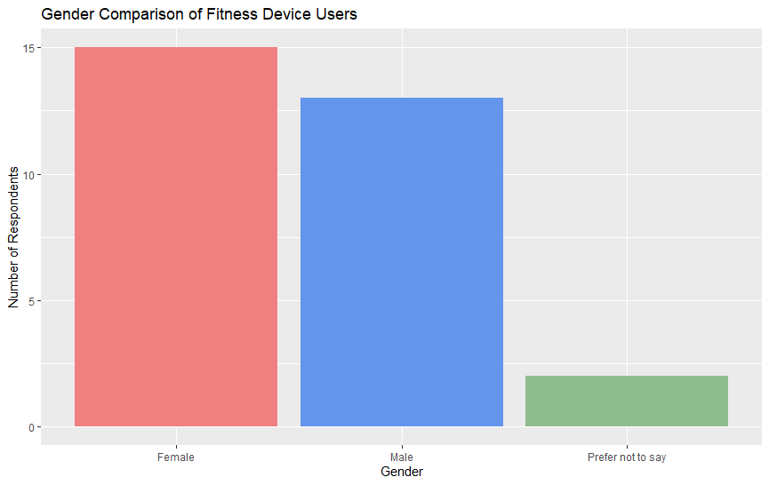

Figure 1: Gender of fitness device survey respondents.

The gender of respondents was almost even between male and female, with there being 15 females and 13 males. Since gender is almost balanced, this data does not indicate a gender imbalance in the larger fitness device population. However, such an imbalance may still exist, as this data consists of a small sample size.

The other demographic I examined was the age of fitness device users. Understanding the age groups that make up the majority of fitness device users would allow Bellabeat to create devices and features that primarily serve the needs of their target demographic.

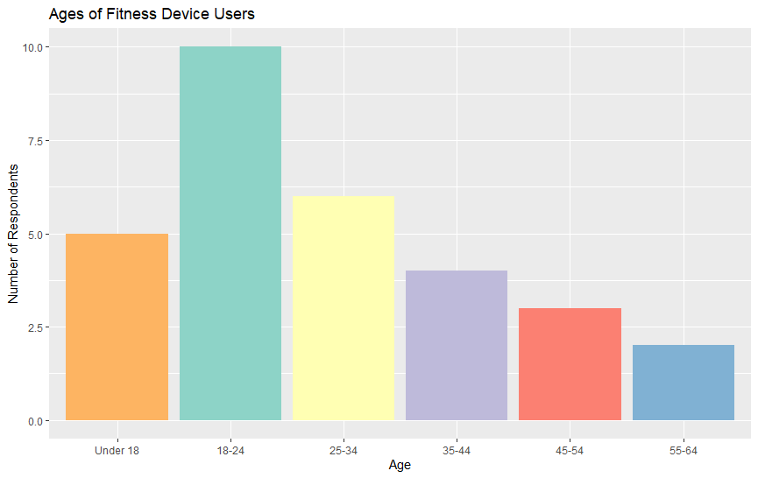

Figure 2: Age of fitness device survey respondents.

As the graph shows, the vast majority of respondents are between the ages of 18 and 24. Therefore, Bellabeat should primarily focus on creating features that cater to this demographic.

Since the exercise survey data also included data on the age of respondents, I decided to compare the ages between these two surveys. If the average age was drastically different for the exercise survey, then the insights gained from that data may not necessarily apply to the fitness device users in the fitness device survey.

Figure 3: Age of exercise survey respondents.

Most respondents of the exercise survey were between the ages of 19 and 25. This matches the age demographic of the fitness device survey, meaning that the responses in the exercise survey will likely be applicable to fitness device users.

# Popularity of FitBit Features

The first aspect of my data I wanted to analyze was the popularity of each of the FitBit features included in the data set. Recognizing which features are most popular would indicate how most FitBit users use their device. Recognizing which features are least popular would highlight which features are less desired, advertised less, or are less effective.

To see the popularity of each feature, I first recorded the number of unique User IDs in each of the features’ data frames. I then graphed the results in a bar chart.

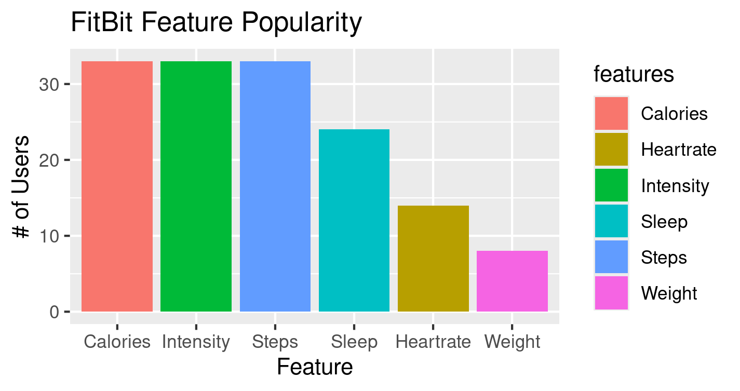

Figure 4: Popularity of each of the 6 FitBit features.

The “Calories”, “Intensity”, and “Steps” features were used by all 33 FitBit users. The “Sleep” feature had 24 users, the “Heartrate” feature had 14 users, and the “Weight” feature had 8 users.

From these findings, I was most interested in the popularities for the “Sleep” and “Weight” features. I was curious as to why these features were less popular than the others. Since it is common for people to complain about not getting enough sleep or gaining too much weight, I believe that understanding why these features aren’t as popular as one might expect them to be would be beneficial for Bellabeat. If there is simply less interest in these features than others, then it may be better for Bellabeat to focus on other features for their products. Or, if there *is* interest in these features, Bellabeat could research what might be making the features less popular in FitBit devices. That way, Bellabeat could create improved versions of these features that address any inadequacies or shortcomings of the current versions of the features.

# Effectiveness of Fitness Device Sleep Features

## Average Hours of Sleep

To understand why FitBit users use the “Sleep” feature less than other features, I first wanted to know how much sleep each user got on average. According to the National Institute of Health, adults should sleep between 7 and 9 hours each night.[1] If FitBit users averaged less than 7 hours each night, this would be considered inadequate sleep and might indicate potential for improving the feature.

I created a new data frame that contained the average sleep for each user. I then converted the amount of sleep from minutes to hours and calculated the average and standard deviation. The average was 6.2 hours with a standard deviation of 2.3 hours.

I then graphed the data in a histogram for a larger picture of the sleep distribution.

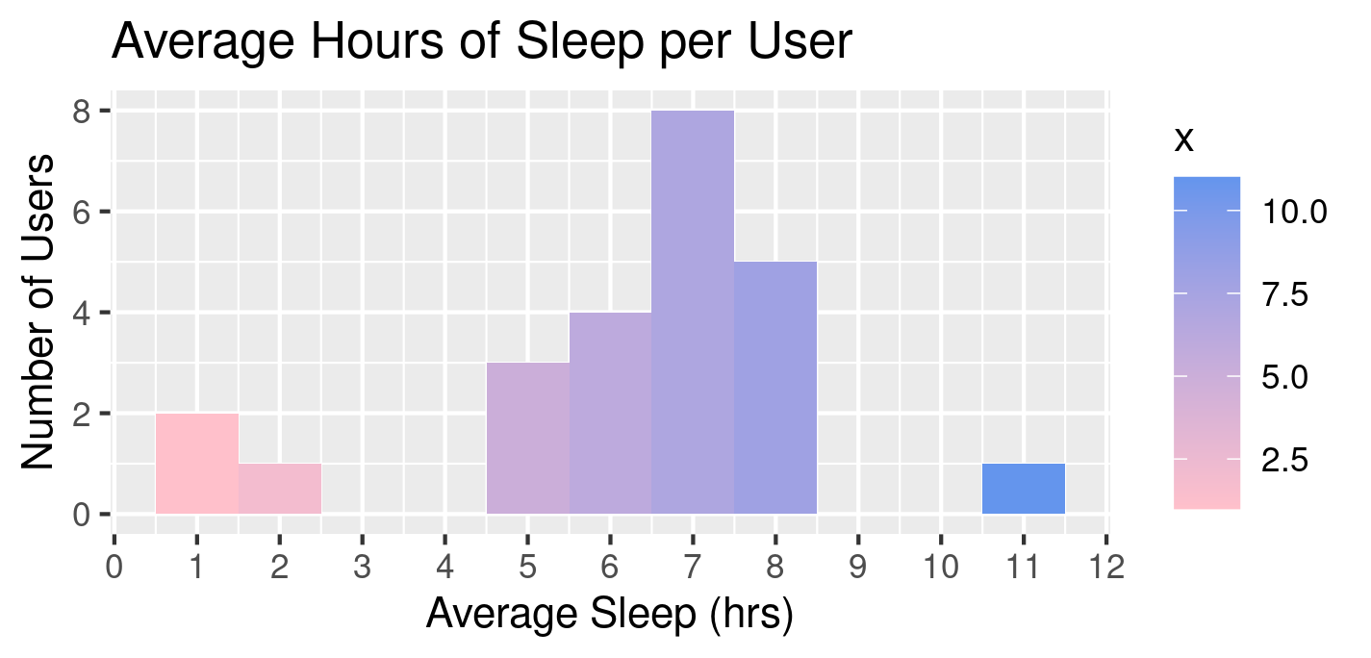

Figure 5: Average hours of sleep for FitBit users.

According to the graph, most users got around 7 hours of sleep. While this falls within the range of adequate sleep, it is right on the bottom limit of it. The standard deviation of 2.3 hours also indicates that a noteworthy number of users gets less than the recommended amount of sleep.

Since the sample size of this data is small, further research should be done to get a more confident picture of how much sleep fitness device users get each night. If the average continues to be on the low end of the recommended range, Bellabeat could invest in improvements to the sleep features in their devices, if they have such features.

## Impact of Fitness Device on Sleep Patterns

To try to get a clearer understanding of how fitness devices impact users’ sleep, I looked at the fitness wearable survey data. One of the survey questions asked whether the fitness device improved the user’s sleep patterns. This was the exact question I wanted to know the answer to. So, I tallied up each of the respondents’ answers and graphed the results. Since Bellabeat tailors their devices to female users, I separated male and female responses to ensure the trends applied to women.

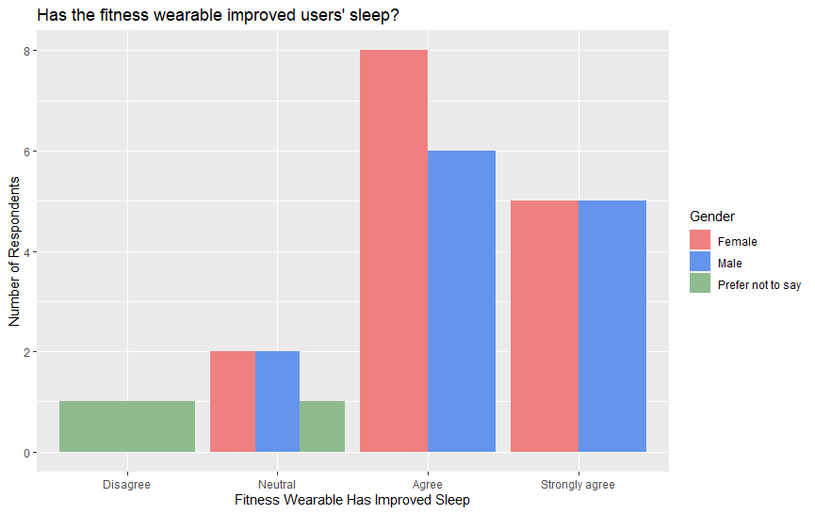

Figure 6: Impact of fitness wearable on user's sleep, by gender.

According to the graph, most respondents agree or strongly agree that their fitness device improved their sleep patterns. This trend is true both in general and for women specifically. After calculating the percentage of respondents who agree or strongly agree, it was revealed that a whopping 80% of respondents fell into either of these categories.

The fitness wearable survey data also included information about how long the user has owned their device. I decided to graph another version of this graph with the length of device ownership highlighted to see if the length of ownership correlated with stronger feelings.

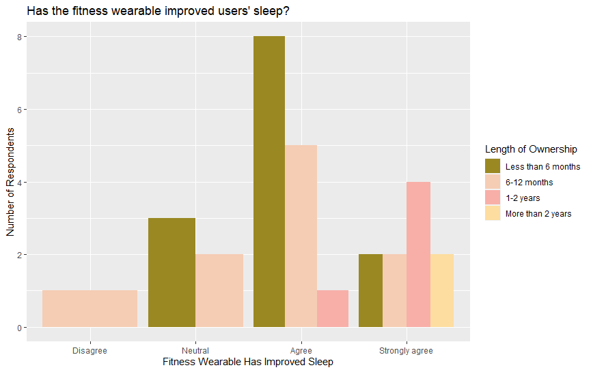

Figure 7: Impact of fitness device on user's sleep, by length of device ownership.

This graph shows us that the longer a user owns their fitness device, the more likely they are to claim that it improves their sleep patterns. Even most users who have owned their device for less than 6 months agree that their device has improved their sleep.

These two graphs show that fitness devices improve users’ sleep patterns, which leads to a couple of takeaways. First, if Bellabeat does not already have sleep tracking features in their devices, it would be beneficial for them to implement them. Second, the effectiveness of fitness device sleep features versus their comparative popularity among users may be due to them being less advertised features. Further research would be necessary to confirm this, however.

# Exercise Motivation & Weight Loss

## Motivators for Exercise

One of the questions asked in the exercise survey data was “What motivates you to exercise?” I found this information incredibly important for this analysis, since Bellabeat could incorporate these motivators in their devices to help users continue to exercise and use their products. I also believed that analyzing these motivators may reveal potential for new features in Bellabeat devices.

Since the list of motivators for each user was contained in a single column in the data frame, I first had to split the string and assign each possible response to a new column. Then, if a respondent included a given response in their answer, the corresponding column was marked with a 1. Otherwise, it was marked with a 0. I then removed columns from the resulting data frame so that it was just the responses and demographic information I might use.

Because Bellabeat designs devices primarily for women, I wanted to include gender in the graph of the motivators. That way, I would ensure that the most popular motivators I highlight pertain to women.

To make the bar chart, I grouped the data by gender. Then, I tallied the number of respondents for each motivator column. Since some motivators were very similar, I summed those columns together and assigned the total to one column. I then transposed the data frame and reformatted its columns and rows.

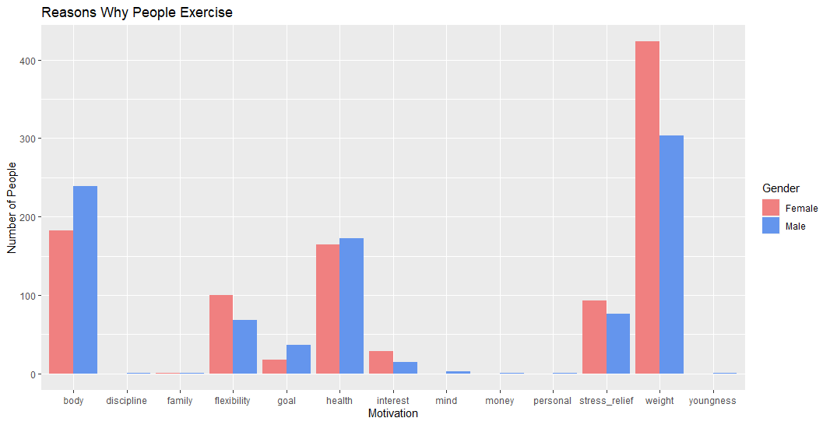

Figure 8: Motivators for exercising, by gender.

This graph clearly shows that the most popular motivation for exercise is to lose weight. In total, 423 women said weight loss was one of their motivations. The next most popular motivation is body image, which is closely related to weight. In total, 182 women said body image was one of their motivations.

## Motivation of Weight Loss vs. Weight Feature Usage

An interesting comparison to make is that despite weight being far and away the most popular motivation for exercise, Figure 4 tells us that it is the least used FitBit feature. This leads to the question of why this feature is used so little? One possibility is that FitBit’s weight feature does not properly address their users’ needs. Another possibility is that FitBit does not advertise this feature effectively, so users may not know it exists. A third possibility is that the feature involves manual user entry rather than automatic entry, which may deter some users. Further research should be done to find the cause of this divergence in expectations. For now, though, Bellabeat should ensure they implement features in their devices that help users track their weight and give them tips on how to lose weight. They should also ensure that these features meet the consumers’ needs. If they do not meet them, research should be done to reveal what changes must be made to better address them.

## Impact of Fitness Device on Exercise Motivation

Knowing some of the most popular reasons why people exercise could be useful for Bellabeat. For example, they could implement a feature that allows users to select their top motivations for exercising from a list of options. These options can be taken from the most popular responses in Figure 8. If a user does not exercise after a certain length of time, their device could send them a reminder of why they initially wanted to exercise. This may motivate them to continue exercising.

To test whether a feature like this would be useful, I analyzed the responses to the question “Has the fitness wearable helped you stay motivated to exercise?" from the fitness device survey data. I plotted two versions of a bar graph containing the responses. One graph showed responses by gender and the other showed responses by the length of device ownership.

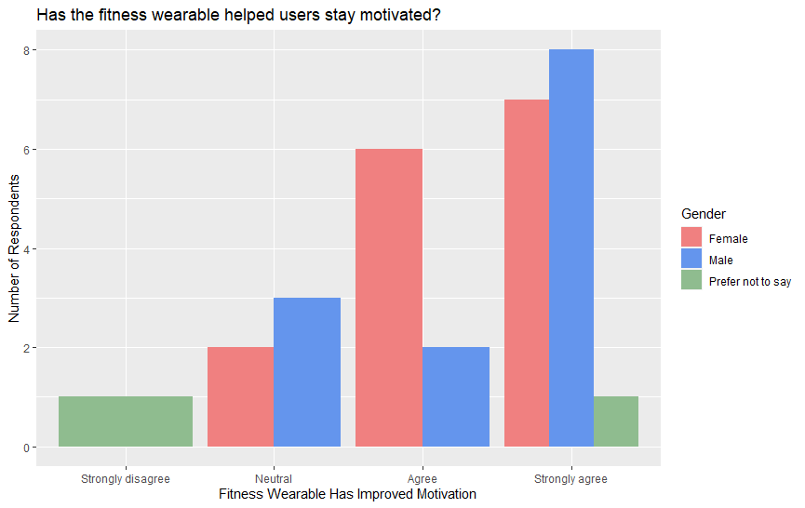

Figure 9: Impact of fitness wearable on motivation to exercise, by gender.

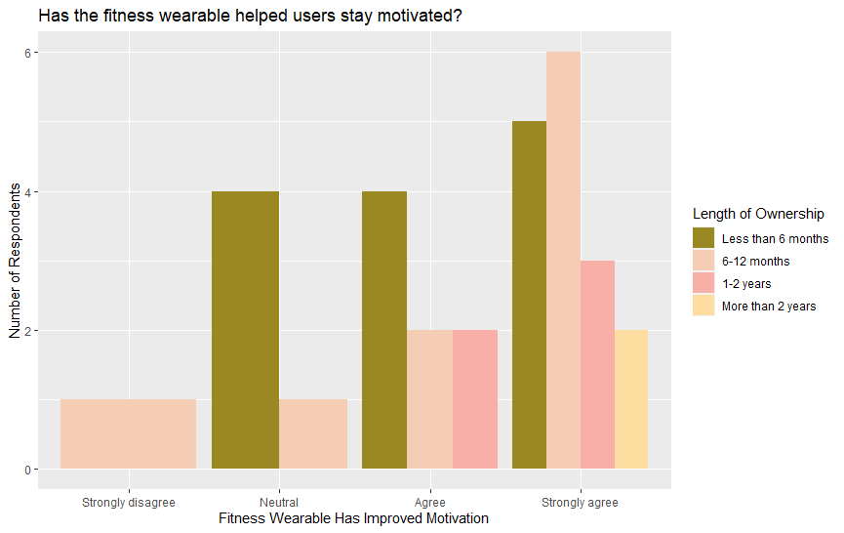

Figure 10: Impact of fitness wearable on motivation to exercise, by length of device ownership.

Both graphs show that most fitness wearable users agree or strongly agree that their device has helped them stay motivated to exercise. To find how many users fall into these categories, I calculated the percentage for each category and summed them up. This revealed that 80% of respondents claim their device helps them stay motivated.

The majority of both men and women agree that their fitness wearable keeps them motivated to exercise. There is also a trend where the longer someone owns their fitness device, the more likely they are to agree that it keeps them motivated.

Since most users find that their fitness device helps keep them motivated to exercise, it would likely be worthwhile for Bellabeat to implement motivational features in their devices.

# Barriers to Exercising

In addition to analyzing motivations for exercising, I was also interested in what barriers people face in exercising regularly. Based on the responses, Bellabeat could implement features that help users overcome these barriers.

Like the data on user motivations, the data on their barriers was contained in a single column with multiple responses listed in a single string. I followed the same process as with the motivation data to parse the barrier data and graph the results. For this graph, I used a stacked bar graph to represent how each gender contributes to the overall total for each barrier.

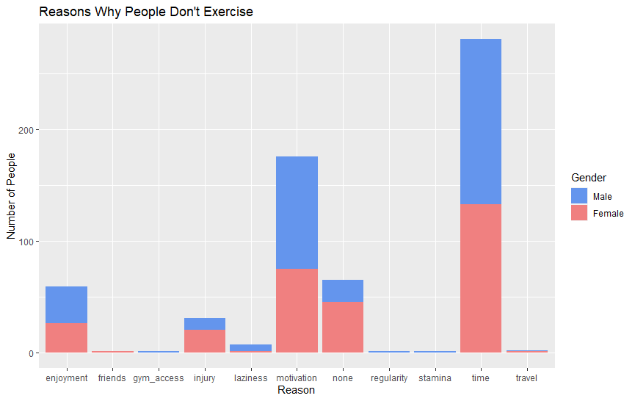

Figure 11: Barriers to exercising, by gender.

The top barriers for both men and women were time and motivation. 133 women reported time as one of their barriers and 75 women reported motivation as one of their barriers.

Bellabeat could help users overcome the barrier of motivation by implementing the motivational features discussed in the previous section. To address the barrier of time, Bellabeat could implement a schedule system in their devices. Users could set an exercise schedule that they can customize to fit their needs and daily life schedule. When the day or time they set to exercise arrives, their device can remind them. This feature would also work well with the motivation feature. If a certain number of exercise sessions are missed, the device could include reminders of the user’s motivations to exercise with the reminder that it’s time to exercise.

# Conclusion

The main findings of this analysis are as follows:

* The average age of fitness device users is between **18 and 25 years old**.
* The FitBit **weight** feature is the **least used feature**.
  + The FitBit **sleep** feature is also **used less** than other features.
* FitBit users average 6.2 hours of sleep each night, but most get around **7 hours**.
* **80%** of fitness device users say their device **improves their sleep** patterns.
* The two most popular motivators for exercising are **weight loss** and body image.
  + This leads to the question of why, then, FitBit’s weight feature sees such **little use**.
* **80%** of fitness device users say their device **improves their motivation** to exercise.
* The two most common barriers to exercising are **time** and **motivation**.

Bellabeat requested that I analyze trends in fitness device user data to guide them in future marketing and the implementation of new features for their devices. From my analysis, I suggest the following courses of action for Bellabeat:

1. If not already implemented, implement sleep and schedule features.
2. Implement a motivation feature.
   1. When a user signs up, prompt them to select their motivators for exercising.
   2. When the user’s exercise frequency decreases, encourage them with their motivator(s).
   3. Stretch goal: implement a goal-setting feature if not already implemented.
3. Further research into why FitBit’s weight feature sees little use.
   1. Use these insights to implement a more effective weight feature.

1. <https://www.nhlbi.nih.gov/health/sleep/how-much-sleep#:~:text=Experts%20recommend%20that%20adults%20sleep,or%20more%20hours%20a%20night>